Complex Test (Mid test 5th Form)

Listening

1. Listen to two friend talking in a house and choose True or False

e.g. There is a fireplace in the living room. _T_

1. The kitchen is big. ___
2. David’s bedroom is nest to his brother’s. ___
3. The dog is playing in the garden. ____
4. The dog has got black fur. ____
5. Dan wants to listen to music. ____

Reading

2. Read the email and mark sentences T (true), F (false) or NT
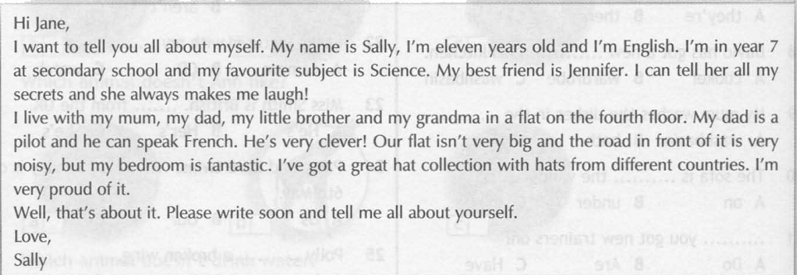
e.g. Sally is from Australia F

1) Sally doesn’t like PE.
2) Sally’s best friend is funny.
3) Sally’s brother can speak French.
4) It is quiet* near Sally’s home.
5) Sally is proud* of her hat collection.
*quiet – довольно, достаточно
*be proud of – гордиться чем-либо

Grammar and Vocabulary
3. Choose the correct item.

1. Mary’s favourite … is English
A group B grade C subject

2. Miss Smith has got …atlas on her desk.
A a B an C two

3. This is Mike and Carla’s car. It’s … car.
A they’re B there C their

4. My mum washes the dishes in the … .
A washbasin B bath C sink
5. Mark makes me laugh. He’s so … .
A funny B noisy C naughty

6. Where are they from? They’re from … .
A Canadian B American C Japan

7. This is my house. It belongs to ... .
A my B me C them

8. Where do you live? I live … New York City.
A over B in C on

9. … are his trainers.
A Those B This C That

10. Bill …his home work in his room.
A do B does C doing

11. Jane and Polly … in the same class.
A is B isn’t C are

12. … you got new trainers on?
A Do B Are C Have

13. My baby sister … walk yet.
A can B don’t C can’t

14. Yes, there … five rooms in my flat.
A is B aren’t C are

15. Miss Smith is British. … from the UK.
A He’s B Her’s C She’s

16. Polly … a broken wing.
A has got B have got C is got

Writing

4. Write an email to a new friend about yourself, your family and about your hobby. (Как пример используйте упр. 2 из этого теста)


