ВПР. АНГЛИЙСКИЙ ЯЗЫК. 7 КЛАСС.
ЗАДАНИЕ 3. МОНОЛОГ
ПРИМЕР ЗАДАНИЯ:
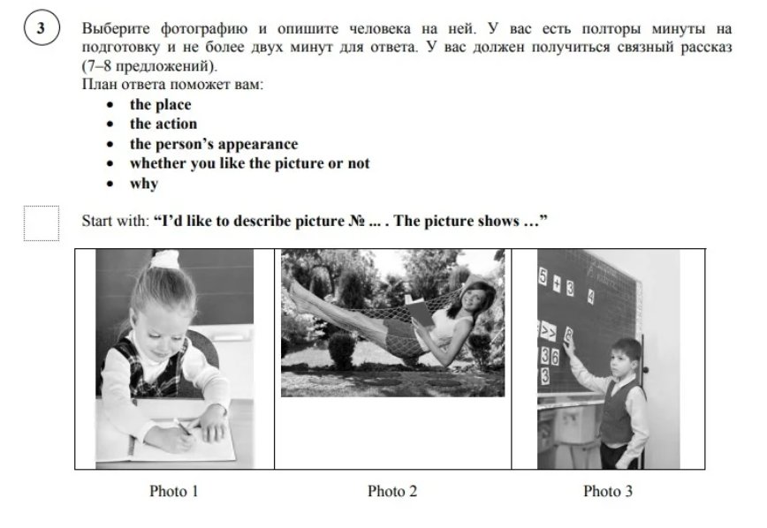
ПРИМЕР ОТВЕТА:
- I’d like to describe picture №1.
- The picture shows us a little girl.
- I guess the photo was taken at school.
- Тhis girl is doing her classwork.
- I reckon the girl is about 7 years old.
- She is wearing a black and white school uniform.
- I like the picture because the atmosphere is peaceful.
- That’s all I wanted to tell about this picture.

ПЛАН ОТВЕТА
1 | Вводное предложение | I’d like to describe picture № ... .  The picture shows us … .  *I guess he/she is a … .  *You can also see … .
2 | Описание места | The picture was taken outside/inside.  In this picture the action is taking place in (the house; the living room; the gym; etc.).
3 | Описание действия | He/she is … .
4 | Описание внешности | The girl/boy is about ____ years old.  She/he is wearing … .  She/he has got … .  I guess she/he is happy/sad.  He looks beautiful/handsome/concentrated e.t.c.
5 | Описание реакции на фото: нравится ли фото и почему | I like this photo because the atmosphere in this photo is amazing/friendly/great.  It makes me think about my summer vacations/family/last holiday.
6 | Заключительная фраза | That is all I wanted to say.

