Module 6. Round the clock
6a. Wake up! (p. 76-77)
SB: p.76 №1
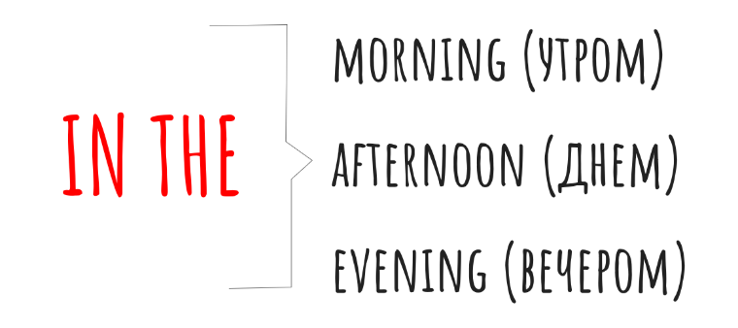
Перед выполнением задания обрати внимание на использование предлогов с частями суток.
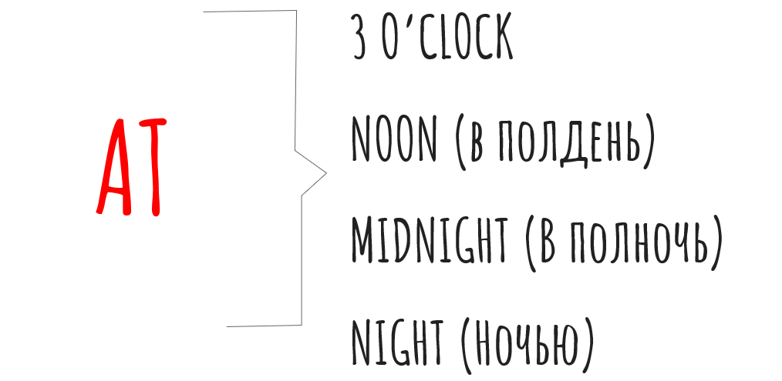

Look at the pictures. You can see Sally’s daily activities. What does she do in the morning/afternoon/evening? Write the answer in your copybook.
e.g. «In the morning she gets up, ... .»
*go jogging – идти на пробежку

Также обрати внимание на разницу между глаголами ‘wake up’ и ‘get up’
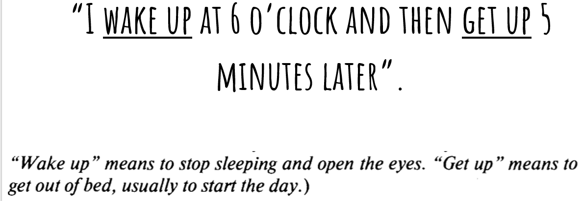
SB: p.76 №2
Let’s remember how to tell the time. Watch a video: https://www.youtube.com/watch?v=Pht7dTlM0VA
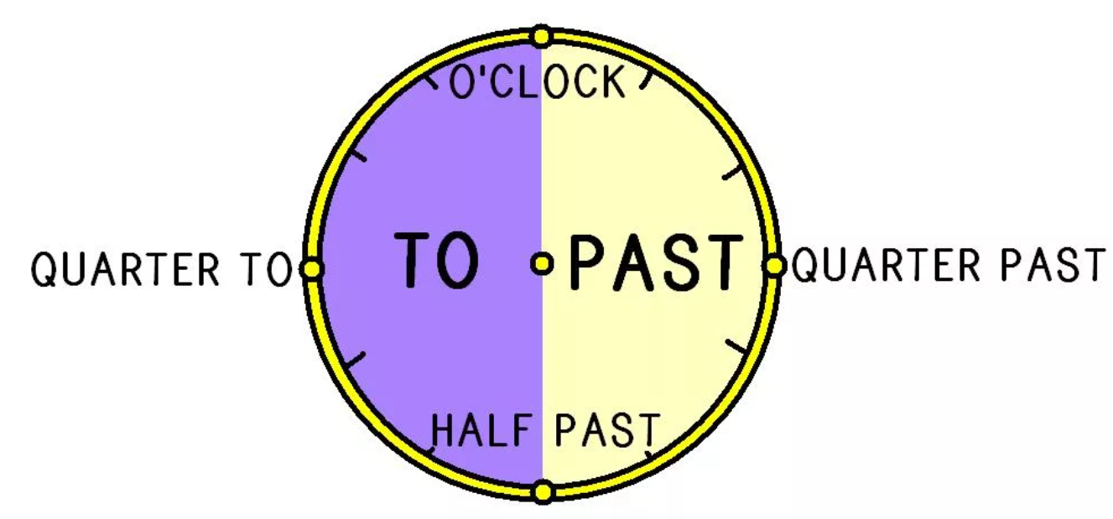
12.45 – It is quarter to 1.
12.30 – It is half past 12.
12.15 – It is quarter past 12.
12.00 – It is 12 o’clock.

Write the time in your copybook.
e.g. “6.30 – It is half past six.”
1) 2.00 - _______________________________________________
2) 2.15 - _______________________________________________
3) 3.30 - _______________________________________________
4) 4.45 - _______________________________________________
5) 6.00 - _______________________________________________
6) 7.30 - _______________________________________________
7) 8.15 - _______________________________________________
8) 9.45 - _______________________________________________

SB: p.76 №4
Listen to the text and fill in the gaps with: past, on, goes, cup, up, has, watches, goes. Listen and check. Then read the text aloud. (Ответы записать в тетрадь в формате «цифра – ответ», аудио прикреплено на форуме).

SB: p.76 №7
Complete the sentences with prepositions at or in saying what you usually do at this time. Write the answers in your copybook.
e.g. “1. ____ 3 o’clock – I usually do my homework at 3 o’clock.”

Домашнее задание на 16.01: Учебник: с.76 №1 (лексика), с.77 №7 (правило в синей рамке) – учить. Печатная тетрадь: с.47 №2, №5, №6.

